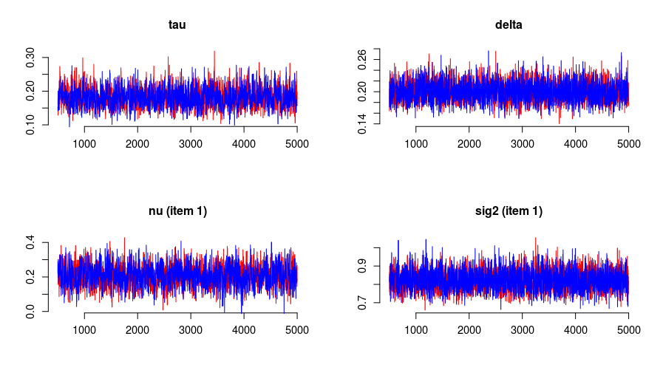N = 500

K = 10

XG = 2 * 5000

Single replication

Simulated, Estimated (SD)

Tau_1: 0.2, 0.181 (0.029)

Tau_2: 0.3, 0.325 (0.04)

Delta_1: 0.2, 0.2 (0.018)

Delta_2: 0.3, 0.301 (0.024)

theta_2: -0.5, -0.457 (0.054)

zeta_2: 0.5, 0.499 (0.032)

Cor. beta: 0.9994318

Cor. lambda: 1

Cor. sig2k_1: 0.9999417

Cor. sig2k_2: 0.9999716

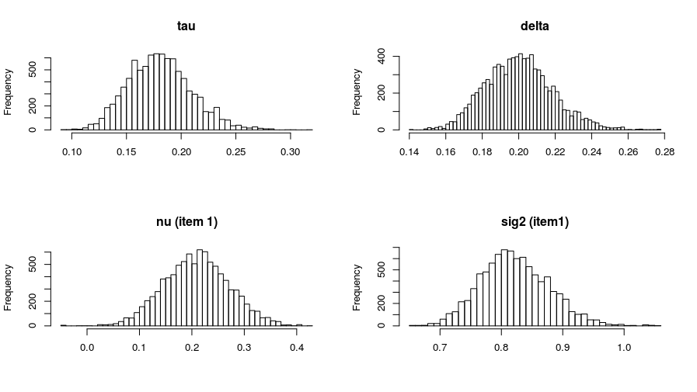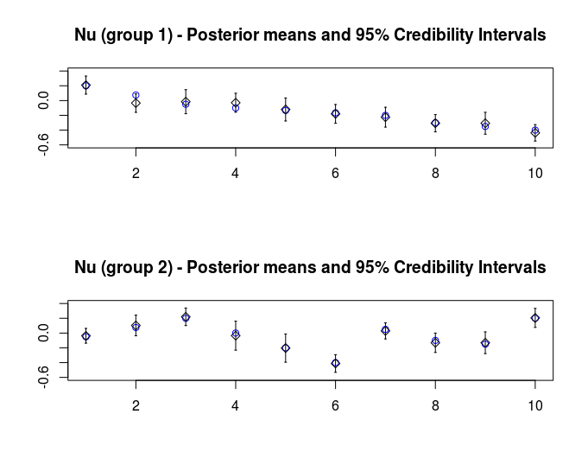

N = 5000

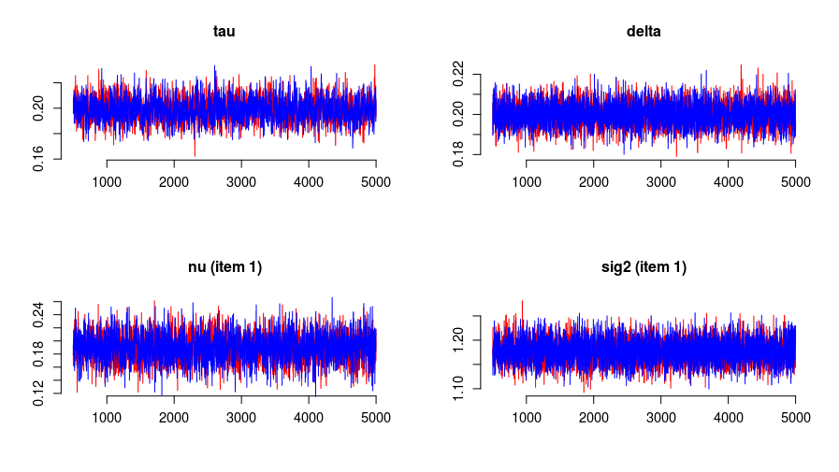K = 10

XG = 2 * 5000

Single replication

Simulated, Estimated (SD)

Tau_1: 0.2, 0.199 (0.009)

Tau_2: 0.3, 0.313 (0.013)

Delta_1: 0.2, 0.2 (0.006)

Delta_2: 0.3, 0.3 (0.008)

theta_2: -0.5, -0.468 (0.018)

zeta_2: 0.5, 0.5 (0.01)

Cor. beta: 0.9999408

Cor. lambda: 1

Cor. sig2k_1: 0.9999996

Cor. Sig2k_2: 0.9999997

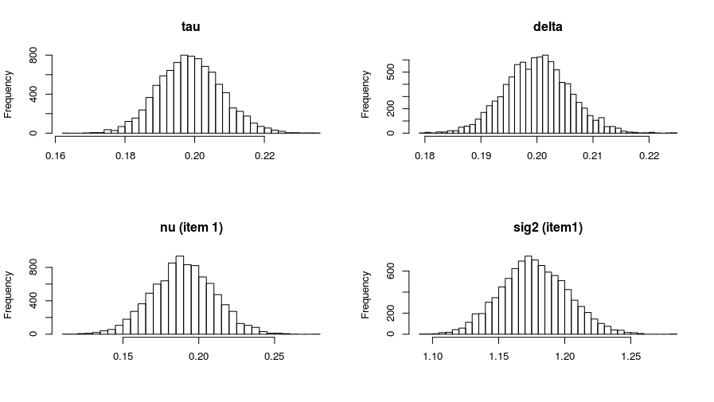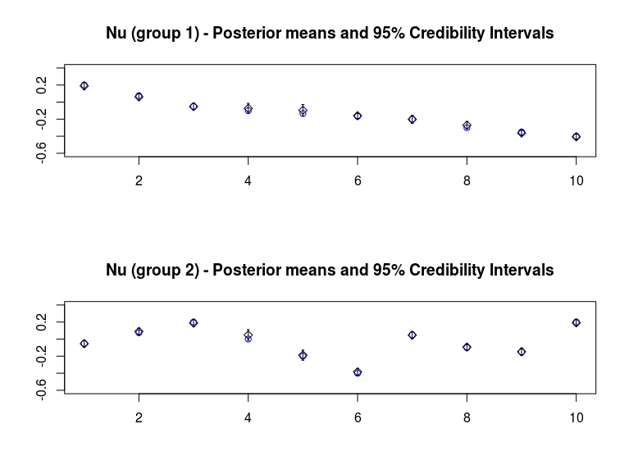

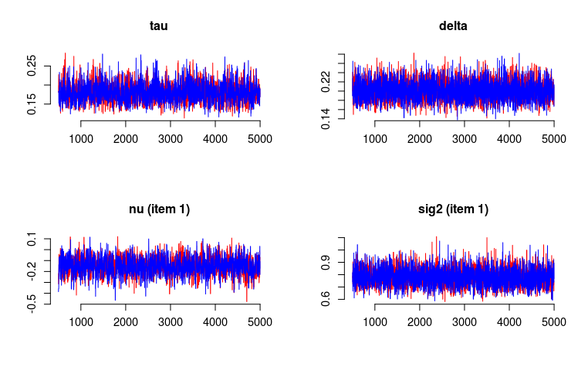N = 250

K = 30

XG = 2*5000

Single replication

Simulated, Estimated (SD)

Tau_1: 0.2, 0.181 (0.025)

Tau_2: 0.3, 0.299 (0.036)

Delta_1: 0.2, 0.201 (0.021)

Delta_2: 0.3, 0.302 (0.031)

theta_2: 0, 0.016 (0.062)

zeta_2: 0.1, 0.099 (0.038)

Cor. beta: 0.998925

Cor. lambda: 0.9999996

Cor. sig2k_1: 0.9999786

Cor. Sig2k_2: 0.9999663

